

MAKING DISCIPLES OF JESUS CHRIST FOR THE TRANSFORMATION OF THE WORLD

SERMON

GRAPHIC

WORSHIP PASSIONATELY - SERVE AUTHENTICALLY - DEMONSTRATE UNWAVERING HOSPITALITY

Our mission is to empower all people to experience the transformative
love of Jesus Christ through service, tradition, and education.

Our vision is to serve as a diverse community of faithful people
who worship passionately, serve authentically,
and demonstrate unwavering hospitality.

December 28, 2025
First Sunday after Christmas
“Behold a New Thing”


BFUMC Kids

Children’s Moment

Children Pre-K to 5th grade are invited to join Ms. Susan for the Children’s Moment and then depart to room 201 for Children’s Church. We will do a Bible story, craft, and games. Parents may pick up their children in room 201 in the Christian Life Center at the end of each worship service.

On Communion Sunday: Children will return to the Sanctuary and be seated with their parents so that they can receive Communion and then remain for the rest of the worship service.

Nursery: A nursery is provided for children age 3 and under in room 202 of the Christian Life Center.

For more information, contact Susan Rosenthal, children.director@bufordfirstumc.org

We hope you had a wonderful Christmas!

We resume school on January 5, 2026.

For more information, contact Leandre Majerus, preschool@bufordfirstumc.org





Student Ministry

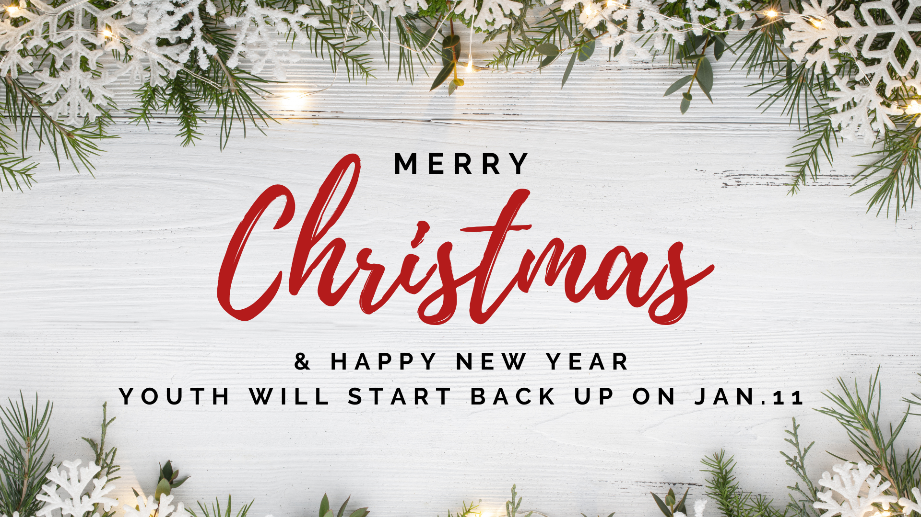

For more information, contact Brendan Rossell Smith, studentministry@bufordfirstumc.org

Missions

Thank you to everyone who served in a Christmas Missions Project this year! As a church body, we were able to provide Christmas gift support to over 20 families with over 300 angels from the Angel Tree, over 700 meals to our non-profit community partners (ex: women’s and children’s shelters) and individuals in need in the community, and funding for 5 other missions organizations through the Alternative Christmas project.
Thank you to everyone who contributed to these projects!

If you would like to learn more about how to get plugged in and serve in 2026, reach out to Sydney! We have our weekly feeding mission Sack Kids Hunger, our free community English classes, and so many other missions projects that you can serve in!

For more information, contact Sydney Yancey, mission@bufordfirstumc.org

Adult Ministry

Daniel & Revelation Bible Studies: There are two Bible study options to choose from that started back in the Fall. For each Bible study, we will be going through the second half of the book starting in January. Revelation (Part 2) - Facilitator: Brendan. Tuesdays at 6:00pm in the CLC Media Room (312). Daniel (Part 2) - Facilitator: Pastor Jim. Wednesdays at 10:00am in the CLC Media Room (312). Part 2 of the Revelation and Daniel Bible studies will start 1/6 and 1/7, respectively. You can join in the Bible studies even if you did not do Part 1 in the Fall. The facilitators just ask that you let us know so that we can provide you with materials from Part 1 so you can get caught up with the rest of the group!

The Florence Garner Circle will be hosting Ladies Game Night 1/9 at 6:00pm in the Fellowship Hall. Bring a dish to share, a favorite board game, and consider inviting a friend. All ladies are invited!

Young at Heart: Bunco and Lunch - Tuesday, January 20. RSVP with your sandwich choice. Cost: $15.00 for a box lunch from Main Street Deli, drink, and prizes. Box lunch includes sandwich (ham/provolone or turkey/swiss on wheat bread), potato chips, chocolate chip cookie, and a pickle. Time: 11:00am - 2:30pm. Please RSVP with your choice of sandwich to Debbie Atcheson by January 13 at: djatcheson@gmail.com or 770-965-3729.

For more information, contact Sydney Yancey adultministry@bufordfirstumc.org

The Worship of God

December 28, 2025 10:00am

First Sunday after Christmas | Liturgical Color: White

Hearing devices and large print hymnals are available in the narthex.
If you have trouble hearing the sound, please alert an usher for help.
Please place your electronic devices on silent mode and
refrain from flash photography during worship.
† Stand as you are able.

Chiming of the Hour Hank Morgan, Organist

Prelude “Gloria Fanfares” by Charles Callahan Organist

Welcome and Announcements Rev. Jim Buckman

†Call to Worship (p.817) Psalm 97:7-12 Joan Burger

†Hymn of Praise
UMH No. 240 “Hark! The Herald Angles Sing” all verses MENDELSSOHN

†Affirmation of Faith No. 881 “The Apostles’ Creed” Leader

I believe in God the Father Almighty, maker of heaven and earth; And in Jesus Christ his only Son our Lord: who was conceived by the Holy Spirit, born of the Virgin Mary, suffered under Pontius Pilate, was crucified, dead, and buried; the third day he rose from the dead; he ascended into heaven, and sitteth at the right hand of God the Father Almighty; from thence he shall come to judge the quick and the dead. I believe in the Holy Spirit, the holy catholic church, the communion of saints, the forgiveness of sins, the resurrection of the body, and the life everlasting. Amen.

†Gloria Patri No. 70 “Glory Be to the Father” MEINEKE

Glory be to the Father and to the Son and to the Holy Ghost;
as it was in the beginning, is now, and ever shall be, world without end. Amen. Amen.

Children’s Moment Susan Rosenthal

Time of Silent Prayer · Pastoral Prayer · The Lord’s Prayer Rev. Buckman

Our Father, who art in Heaven, hallowed be thy name. Thy kingdom come, thy will be done on earth as it is in heaven. Give us this day our daily bread, and forgive us our trespasses, as we forgive those who trespass against us. And lead us not into temptation, but deliver us from evil. For thine is the kingdom, and the power, and the glory, forever. Amen.

Gathering of Tithes and Offerings Clare Shappert, soloist
“O Holy Night” arr. Foster & Lubbock

†Doxology No. 95 OLD 100th

Praise God, from whom all blessings flow; praise him, all creatures here below;
praise him above, ye heavenly host; praise Father, Son, and Holy Ghost. Amen.

†Prayer of Consecration Rev. Buckman

†Scripture Reading Isaiah 43:10-19 Sydney Yancey

Message In Song “One King” arr. Barrett & Angerman Chancel Choir

Sermon “Behold a New Thing” Sydney Yancey

†Hymn of Discipleship
UMH No. 246 “Joy to the World” vs. 1, 2 & 4 ANTIOCH

Benediction Sydney Yancey

Postlude. “From Heaven Above to Earth I Come” arr. Jacob B. Weber Organist

Worship Preview

January 4 Testify: “Making It The Greatest”” John 1:15-18
January 11 Testify: “You Bring Me Great Pleasure” Matthew 3:13-17

Stephen Ministers for this week: If you would like someone to pray with you over the phone, discuss concerns in your life, or just learn more about the Stephen Ministry please contact
Deena Rindfusz (404-375-6248) or Pat Stanley (404-406-9216).



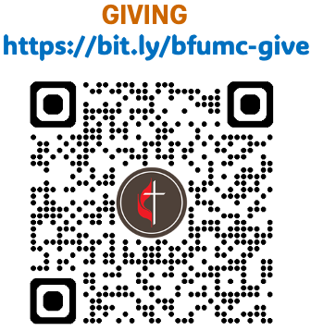






10:00am Worship

Acolytes – Darla Hiltgen (crucifer), Ken Hiltgen (light) | Greeters – Suzanne Clegg, Jack Rindfusz
Ushers – Chris Simonson, Rowan Simonson | Sound – John Alford
Brad Thomas, Michael Thomas | Liturgist – Joan Burger
Children’s Church – Jonathan Lenz, Susan Rosenthal

Ministry Staff

Senior Pastor | Rev. Jim Buckman | Director of Preschool | Leandre Majerus
Director of Adult Ministry | Sydney Yancey | Facility Manager | Will Rogers
Director of Children & Family Ministry | Susan Rosenthal | Financial Secretary | DeeAnna Page
Director of Student & Outreach Ministries | Brendan Rossell Smith | Office Manager | Roy Foster
Interim Director of Music & the Arts | Jean Ann Crites | Organist | Hank Morgan

Attendance and Giving
December 21, 2025

How precious is your steadfast love, O God!
All people may take refuge in the shadow of your wings.
Psalm 36:7
Offerings & Needs (Budget for 2025)
Needed for Mission, Ministry & Administration $ 803,285
Year to Date Received for 2025 Budget $ 761,683
Weekly Consistent Need to reach the Yearly Goal $ 41,602
Amount Received on December 21, 2025 $ 31,169

Building Fund
Building Debt $ 1,357,130
Available Funds for Building Debt $ 540,523
Amount Received on December 21, 2025 $ 53,076

- The amount needed by the last Sunday of the year is the combined total of our financial needs of Conference Apportionments as well as all other needs.
- The Amount Received should be the complete total of funds contributed for budgetary purposes.
- The Weekly Consistent Need to reach the Yearly Goal will change each week based on the number of weeks left in the year, offset by all financial gifts received.

Contribution Options
- You may place your check in the offering plate or mail it to:
PO Box 329, Buford, GA 30515-0329.
MAIL CANNOT BE DELIVERED TO OUR STREET ADDRESS
- You may setup online bill pay through your bank.
- Give online through our website. We accept Electronic Fund Transfers from checking accounts, as well as debit and credit cards. (Please note that you will get full credit, but a transaction fee is subtracted from the amount the church receives.) https://bit.ly/bfumc-give
- Give By Text. You simply text the amount you wish to give to:
770-628-0752. (Please note that you will get full credit, but a transaction fee is subtracted from the amount the church receives.) https://bit.ly/bfumc-give
- BFUMC Charitable Fund. It allows you to increase your giving and tax deduction by donating stocks, bonds, and mutual funds directly to the church. Another opportunity to give and reduce taxable income is for anyone over the age of 72, who is required to take annual minimum distributions out of their IRA, may designate all or part of that amount to our church.

Prayer Requests

“…but in everything, by prayer and supplication with thanksgiving let your requests be known to God.”
Philippians 4:6

December 28, 2025
Name

If you would like us to send a note of encouragement, please provide the name and address of the person in need.

____Yes, please send a note to

__________________________________________
__________________________________________
__________________________________________

Our prayer volunteers and staff will be praying for your request. Confidential prayer requests will be given to the pastor only.

Confidential? ______Yes

Request
__________________________________________
__________________________________________
__________________________________________
__________________________________________
__________________________________________
__________________________________________
__________________________________________
__________________________________________
__________________________________________
__________________________________________
__________________________________________
__________________________________________
__________________________________________

Total in Worship Services 262
Average Worship Attendance 245

December 28, 2025

GUEST & MEMBER REGISTRY

I attended the 10:00am service

Name

Name

Children

Children

Guest of
First Time Visitor
Attend, but Not a Member
New Resident in Community
Wish to Know More About the Church
Desire a Call
I am a Member of this Church

If you are new or your contact info has changed:

Address

Phone

E-mail ______________________________________

If you would like to join BFUMC, please fill out the membership card located in the church pew, or call or email the church office.

CHURCH OFFICE
770-945-7438 ~ office@bufordfirstumc.org
Monday – Thursday 8:30am – 5:00pm
(Closed on Friday)

PRESCHOOL OFFICE
770-945-4161 ~ preschool@bufordfirstumc.org

FACILITY CONCERNS
facility@bufordfirstumc.org

MAILING ADDRESS
PO Box 329, Buford, GA 30515-0329
(MAIL CANNOT BE DELIVERED TO OUR STREET ADDRESS)

ONLINE
bufordfirstumc.org
facebook.com/bufordfirstumc
instagram.com/bufordfirstumc
youtube.com/@bufordfirstunitedmethodist8610

Events of the Week

SUNDAY 12/28
9:30am Chancel Choir Rehearsal (Sanctuary)
10:00am United Methodist Worship (Sanctuary & Online)
11:00am FPC Pentecostal Preparation (108 FH, 110 Gym, 23)
11:00am Korean United Methodist Worship (306)
2:00pm FPC Pentecostal Worship (108 FH, 109, 110 Gym, 202, 203, 23)

MONDAY 12/29
CHURCH OFFICE CLOSED
PRESCHOOL BREAK
5:00pm Ladies Strength Training (G1)
5:30pm AA 5:30@Main St. (304)

TUESDAY 12/30
CHURCH OFFICE CLOSED
PRESCHOOL BREAK
Pickleball Open Gym (groupme)
5:00pm Ladies Strength Training (G1)
7:00pm AA Sober Dads (304)

WEDNESDAY 12/31

CHURCH OFFICE CLOSED
PRESCHOOL BREAK
5:30pm AA 5:30@Main St. (304)
7:30pm S-Anon (309)

THURSDAY 1/1

CHURCH OFFICE CLOSED
PRESCHOOL BREAK
Pickleball Open Gym (groupme)
5:00pm Ladies Strength Training (G1)
6:30pm FPC Pentecostal Preparation (Sanctuary, 108 FH, 202, 203, 23)
7:30pm FPC Pentecostal Worship (Sanctuary, 108 FH, 202, 203)

FRIDAY 1/2
CHURCH OFFICE CLOSED
PRESCHOOL BREAK

SATURDAY 1/3
10:00am Sack Kids Hunger (107, Parking Lot)
10:30am Al-Anon The Flip Side AFG (304)

SUNDAY 1/4
9:00am United Methodist Worship (Sanctuary)
10:00am Sunday School (109, 201, CLC 3rd Floor)
11:00am FPC Pentecostal Preparation (108 FH, 110 Gym, 23)
11:00am Korean United Methodist Worship (306)
11:00am United Methodist Worship (Sanctuary & Online)
12:15pm Removal of the Greens (Sanctuary)
1:00pm Girl Scouts Troop 23198 (305)
2:00pm FPC Pentecostal Worship (108 FH, 109, 110 Gym, 202, 203, 23)





v2

